Lesson 6
Trigonometric Identities

sPECIFIC OBJECTIVES:
At the end of the lesson, the student is expected to:
- Prove that a given trigonometric expression is an identity.
- Develop and apply the formula for the sum and difference of two angles in simplifying trigonometric expression and verifying an identity.
- Develop and apply double- and half- angle formulas in simplifying trigonometric expressions and verifying an identity.
- Develop and apply product/sum formulas in simplifying trigonometric expressions and verifying an identity.

6.1 Trigonometric Identities
Definition 6.1 Identities

An identity is a relationship that is true for all permissible values of the variable(s).

6.2 Basic Trigonometric Identities

Reciprocal Identities Pythagorean Identities

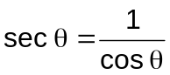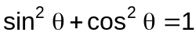
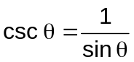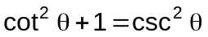
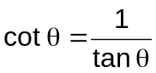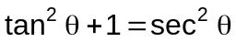

Quotient or Ratio Identities Negative Argument Identities

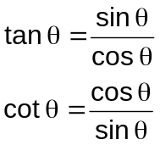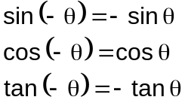

Remarks:

There is no set procedure to prove identities. However, there are several strategies to use when proving identities.
- Know the fundamental identities and look for ways to apply them.
- Write all expressions in terms of sines and cosines.
- If you choose to work with only one side of an identity, continuously refer back to the other side to see what you are trying to obtain.
- When one side contains only one trigonometric function, attempt to rewrite all the functions on the other side in terms of that function.
- Use Pythagorean identities to substitute for the expressions equal to 1.
- Perform algebraic operations.
  - Factor
  - Simplify complex rational expressions.
  - Find the LCD and combine fractions.
  - Combine like terms.
  - Multiply both numerator and denominator by the same expression to obtain an equivalent fraction.
  - Replace a binomial with a monomial.

Proving an identity is not the same as solving an equation. Thus, such equation-solving techniques as operating on both sides are not to be used in the proof of an identity.

Example 6.2 Prove the following identities.

a) 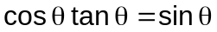 g) 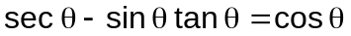

b) 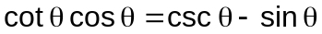 h) 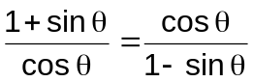

c) 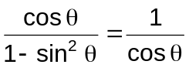 i) 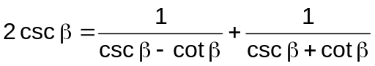

d) 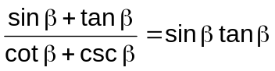 j) 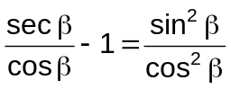

e) 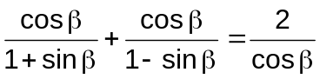 k) 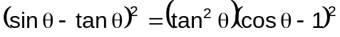

f) 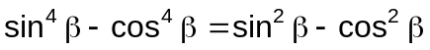 l) 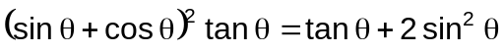

Definition 6.2 Sum and Difference Identities

Sum and Difference Identities

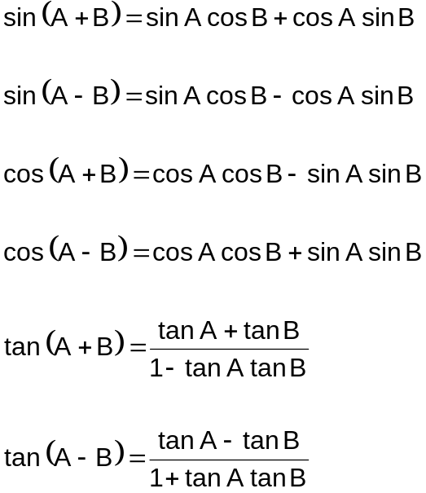

Example 6.2.1 Use sum or difference identities to find the exact value of the given function.

a) cos 105° b) sin 15° c) tan 375°

Example 6.2.2 Given that sin A = 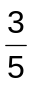 , tan B = 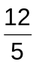 , 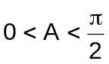 , and 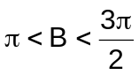, find the following:

a) sin (A + B) c) cos (A – B)

b) tan (A –B) d) Quadrant of A – B

Example 6.2.3 Write each expression in terms of a trigonometric function of one angle.

- sin 80° cos 25° + cos 80° sin 25°

- cos 34° cos 48° - sin 34° sin 48°

- cos cos 3 + sin sin 3

- 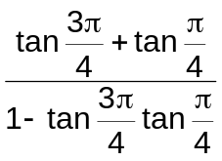

Example 6.2.4 Prove each identity.

a)

b)

c) 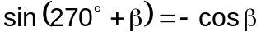

d) 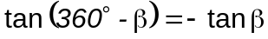

Definition 6.3 Double Angle Identities

Double Angle Identities

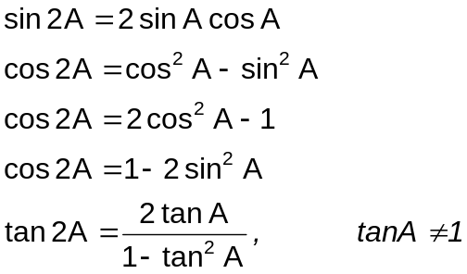

Example 6.3.1 Write each expression in terms of a trigonometric function of one angle.

a) 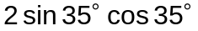 c) 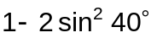

b) 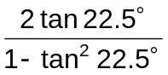 d) 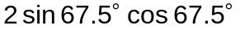

Example 6.3.2 Use double angle identities to find the exact value of each trigonometric function.

a) If 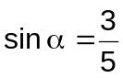 and 0°< < 90°, find cos 2

b) If 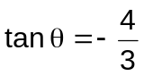 and 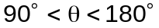, find sin 2

- If 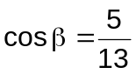 and 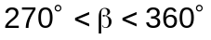 , find tan 2

Example 6.3.3 Prove each identity.

a) 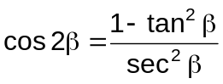

b) 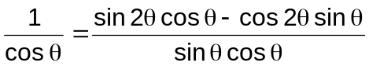

c) 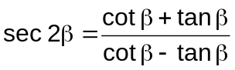

d) 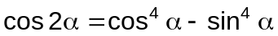

Definition 6.4 Half-Angle Identities

Double Angle Identities

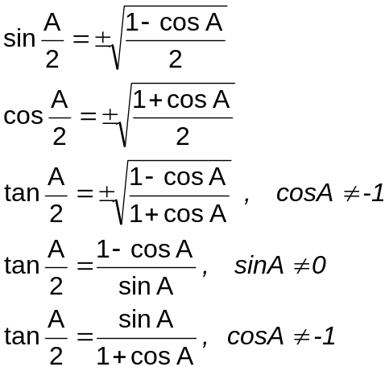

Example 6.4.1 Use half angle identities to find the exact values of the following.

a) 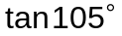 c) sin 22.5°

b) 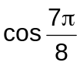 d) 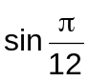

Example 6.4.2 Find the exact value of each trigonometric function. Assume 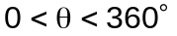.

a) 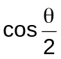 if 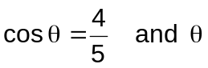 lie in quadrant 1.

b) 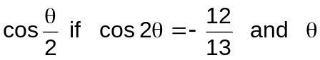 lies in quadrant 3.

c) 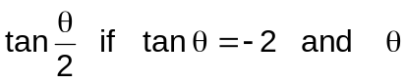 lies in quadrant 2.

Definition 6.5 Product/Sum Identities

Product/Sum Identities

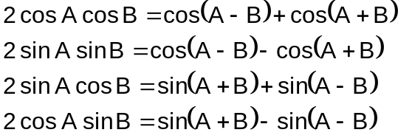

Example 6.5.1 Express each product as a sum or difference.

- 2 sin 50° cos 20°
- 2 cos 40° cos 10°

Example 6.5.2 Express each sum or difference as a product.

- cos 70° + cos 10° c) cos 12x + cos 4x
b) cos 4x – cos 8x d) sin 10x – sin 6x

Example 6.5.3 Prove each identity

a) 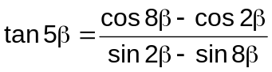

b) 